**Straight Knife Cutting Machine KS-AUV / KS-AUH**

[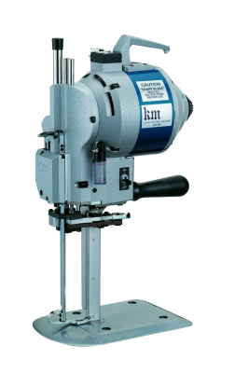](http://www.hashima.co.jp/j/data/wysiwyg/images/products/product0045_01.jpg)

**KS-AU, Straight Knife Cloth Cutting Machine with Automatic Abrasive Belts Sharpenner, is the most popular cutting machine in the Garment Industry. It's suitable for cutting all kinds of fabrics from thin materials to thick materials.**

■ MOTOR　　  
       The Motor is an originally developed Motor. It assures a Smooth Cutting Operation  
　　with Excellent Cutting Power and Low Motor Temperature.  
　  
■ AUTOMATIC OIL LUBRICATION DEVICE  
　　Oil can be supplied Automatically from Oil Reservoir to the Guide Metals and Cross  
　　Head. And the Internal oil Guard keeps other Interior parts clean.  
■ AUTOMATIC SHARPENING DEVICE  
　　There is an Abrasive Belt Sharpening device. Just press down the Sharpening  
　　lever, and the Blade can be shapened Automatically to maintain the most suitable  
　　Edge of the Blade.  
■ STANDARD  
　　Thinner and Flat type Standard makes the Resistance of Cutting ,Material Lower,  
　　and Bigger Blade Stoke makes Cutting Smoothly.  
　  
■ BASE PLATE  
　　The Base Plate is Low and Surface is Smooth to make the Materials travel on it  
　　Smoothly before and after Cutting.

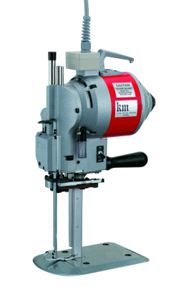  
  
High Power type is also avaiable   
Model : **KS-AUH**  
Power : 800W  
Voltage : 1P220V

## Straight Knife Cutting Machine KS-AUV / KS-AUH

* 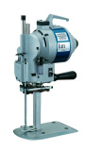

* [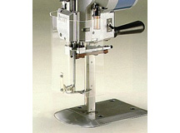](http://www.hashima.co.jp/j/data/wysiwyg/images/products/product0045_03.jpg)

           Knife Guard (Optioin）

|  |  |
| --- | --- |
| **Model** | **Cutting Capacity** |
| **AUV 6"** | 110m/m |
| **AUV 7"** | 135m/m |
| **AUV 8"** | 160m/m |
| **AUV 10"** | 210m/m |
| **AUV 13"** | 290m/m |
| **Power** | 500W  / 800W (KS-AUH) |
| **Voltage** | 100V　200V |
| **Weight** | 14.5Kg |