**Band Knife Cutting Machine KBK-900S, KBK-900M, KBK-900L**

[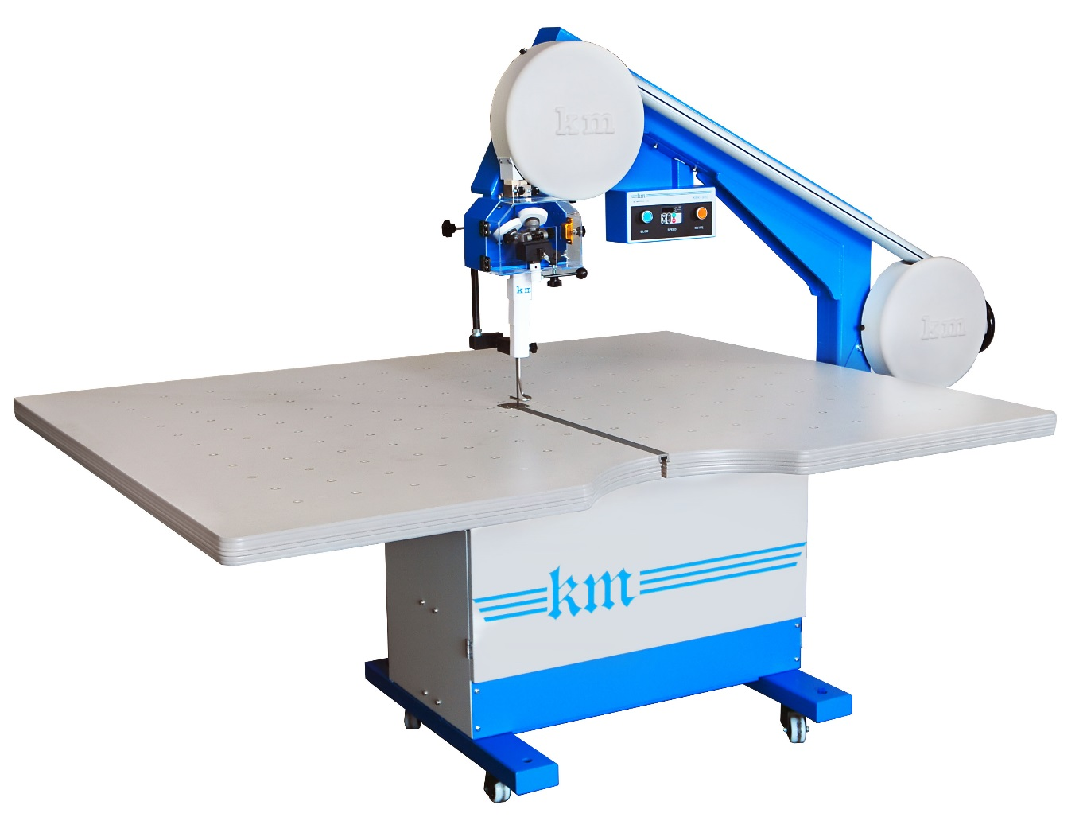](http://www.hashima.co.jp/j/data/wysiwyg/images/products/product0049_01.jpg)

KM Band Knife Cutting Machines is suitable for Exact Cutting of small parts with Air Table.

■ Variable Speed Control (Inverter System)  
    Knife speed is shown on the Digital Indicator and easily controlled by Inverter system  
    according to type of material. Inverter Speed Control System provides Smooth Cutting.  
　  
■ Air Floating Table  
    Air Mat is formed on the table to move Cutting Material lightly, smoothly and   
    provides easy cutting without collapsing the pile of Fabrics.  
　  
■Knife Cooling Silicon Pack  
   Silicon Pack is easily removed and installed. It eliminates the Fusion of Chemical yarn  
   and Interlinig Cloth yarn.  
　　  
■ Easy Knife Exchange  
    A Black Grip Knob at the right of the knife cover provides Easy Knife installation and  
    removable.  
    Knife is loosened by turning the knob Clockwise and tightened by turning  
    Counterclockwise.  
　　  
■ Automatic Sharpening System  
    Originally designed Automatic Sharpening Device is equipped.  
    Various grits of sharpening stone are available to the materials.  
  
■ Carrying Caster  
    Carrying Caster is equipped for easy removal to meet the requirement of relocation.

|  |  |
| --- | --- |
| **Model** | KBK-900S     (Table size 1200 x 1800mm) KBK-900M     (Table size 1500 x 1800mm) KBK-900L     (Table size 1500 x 2100mm) |
| **Cutting Capacity** | 180mm |
| **Table Height** | 720mm-850mm |
| **Arm Length** | 900mm |
| **Knife Speed** | Stepless adjustment |
| **Weight** | 218ｋｇ（９００Ｍ） |
| **Knife Size** | 0.45x10x3860mm |
| **Voltage** | 1P 220V |